2.1 Dataset
The Lipophilicity AstraZeneca dataset was obtained via the Therapeutics Data Commons (TDC) Python API (Huang et al., 2021). It contains 4,200 drug-like molecules with experimentally measured logD values at pH 7.4, originally curated by AstraZeneca (AstraZeneca, 2016) and distributed as part of the MoleculeNet benchmark suite (Wu et al., 2018). The target variable is the octanol-water distribution coefficient logD, which accounts for the ionization state of molecules at physiological pH, making it more biologically relevant than the simple partition coefficient logP (Avdeef, 2003).
2.2 Data Preprocessing
All SMILES strings were converted to RDKit molecule objects using `Chem.MolFromSmiles()`, with invalid entries removed. Canonical SMILES were generated using `Chem.MolToSmiles()` to ensure a unique molecular representation, and duplicate entries were removed by deduplication on canonical SMILES. No molecules were removed from the AstraZeneca dataset, confirming its well-curated nature. No logD range filter was applied, as all measured values are physically meaningful for drug-like molecules (AstraZeneca, 2016). Missing values in the extended physicochemical descriptor matrix were imputed using column medians computed on the training set only to avoid data leakage.
2.3 Molecular Representations
Four molecular encodings were computed from canonical SMILES strings using RDKit and used as input features throughout this study:
- MACCS Keys — a structural key fingerprint of 166 predefined binary substructure patterns, capturing the presence or absence of common functional groups and structural motifs.
- Morgan Fingerprints (ECFP4) — a circular fingerprint of 1024 bits with radius 2, encoding atom-centred circular neighbourhoods up to two bonds from each atom, Morgan fingerprints are the standard representation used for molecular similarity assessment in the cheminformatics literature and were used for all similarity-based analyses in this study (Rogers & Hahn, 2010).
- RDKit Fingerprints — a path-based fingerprint of 2048 bits encoding all linear bond paths up to length 7.
- Extended Physicochemical Descriptors — a set of 101 continuous molecular descriptors computed, covering lipophilicity, molecular size and weight, hydrogen bonding, polarity, surface area, topological indices, ring systems, atom-type counts, electronic properties, drug-likeness, and functional group counts. This descriptor set was intentionally designed to include correlated and redundant features as input to the feature selection pipeline described in Section 2.5. Physicochemical descriptors were standardized using z-score normalization (StandardScaler), with the scaler fitted on the training set only.
2.4 Data Splitting & Similarity Analysis
The dataset was split into training (70%), validation (10%), and test (20%) sets using TDC's standardized splits (Huang et al., 2021), under two strategies. In the **random split**, molecules are assigned randomly to partitions, so structurally similar molecules can appear in both train and test — giving optimistic performance estimates that serve as a baseline comparable to MoleculeNet benchmarks (Wu et al., 2018). In the **scaffold split**, molecules are grouped by their Murcko scaffold and entire scaffold groups are assigned to a single partition, meaning test molecules come from chemical series the model has never seen during training. This produces a more realistic evaluation of generalisation to novel compounds and is the primary split used in this study.

To quantify split difficulty and support applicability domain analysis, we computed the nearest-neighbour Tanimoto similarity of each test molecule to the training set using Morgan fingerprints. These similarity scores were later used to group test molecules by structural similarity and analyse how prediction error changes as molecules become more dissimilar from the training data.
2.5 Feature Selection
Feature selection was applied exclusively to the physicochemical descriptors, as these are the only continuous and potentially redundant features in our pipeline. Fingerprint encodings were used as-is — correlation-based feature clustering is not well-suited for high-dimensional sparse binary vectors where most bits are zero, and tree-based models handle such representations natively without requiring dimensionality reduction.
We used **Clustered Forward Selection (CFS)** — a greedy wrapper method that first groups correlated features into clusters using a Spearman correlation threshold of 0.7, then performs forward selection while enforcing at most one candidate per cluster at each step. This explicitly prevents redundant features from entering the selected set, resolving the substitution effect that would otherwise dilute permutation feature importance scores. The optimal number of features was determined by the peak of the cross-validated R² score curve. All feature selection was performed on the training set only to avoid data leakage.
CFS was applied separately for each model since the optimal feature subset may differ depending on each model's ability to capture non-linear relationships.
2.6 Classic Models
Three models of increasing complexity were trained and evaluated:
- **Linear Regression** — a simple baseline with no hyperparameters, fitting a linear combination of input features. We use it as a reference point to see whether more complex models provide meaningful gains.
- **Random Forest** — an ensemble of decision trees trained on random subsets of features and data, with predictions made by averaging across all trees. It captures non-linear relationships and is robust to high-dimensional input.
- **XGBoost** — a gradient boosting model that builds trees sequentially, with each tree correcting the residual errors of the previous one. It generally achieves stronger performance than Random Forest on tabular data by iteratively reducing prediction error.
All three models were trained on each of the four molecular encodings under both splitting strategies, giving 24 combinations in total. For the physicochemical descriptor encoding, each model used its own CFS-selected feature subset as described in Section 2.5.
As an extension, we additionally evaluated Kernel Ridge Regression, motivated by its use in prior lipophilicity prediction work (Schroeter et al., 2007). Two variants were evaluated on the scaffold split: KRR with a Tanimoto kernel on Morgan fingerprints, and KRR with a Gaussian (RBF) kernel on the CFS-selected physicochemical descriptors. The second variant lets us directly compare a simple kernel method against XGBoost on identical inputs, to see whether the added complexity of gradient boosting is actually needed.

2.7 Graph Models
Graph Neural Networks (GNNs) model each molecule as a graph G=(V,E), where atoms are nodes and chemical bonds are edges. At each layer, node representations are updated by aggregating information from neighboring atoms, allowing the model to learn local chemical environments and construct a global molecular embedding.
Two primary architectures were evaluated:
Graph Convolutional Networks (GCN): Utilizing the update rule:
where adds self-loops to the adjacency matrix and is its degree matrix.
This normalization stabilises training and encourages smooth message passing across bonds.

Graph Isomorphism Networks (GIN): These use a learnable MLP instead
The update is defined as:
After several message-passing layers, node embeddings are summed (instead of pooled) into a fixed-length graph embedding and passed to an MLP head for regression.
We compared three specific implementations to contrast "from-scratch" development with optimised libraries (both on random split and scaffold split as for previous models):
- GCN (Scratch): A custom dense implementation using one-hot atomic number features (54 dims) and a batch size of 1.

- PyG GCN: Implemented via PyTorch Geometric using OGB’s smiles2graph featurisation and sparse batching (size 64).

- PyG GIN: Utilising GINConv with the same high-dimensional OGB atom and bond features.

2.8 Hyperparameter Tuning
Linear Regression has no hyperparameters and was fitted directly on the training set. For Random Forest and XGBoost, we tuned hyperparameters using a grid search over the validation set, selecting the combination that minimised validation MAE. The validation set was used exclusively for this purpose and was never used to report final performance.
The search grids were as follows:
- **Random Forest:** number of trees (50, 100, 200, 500), maximum tree depth (None, 5, 10, 20), and minimum samples per leaf (1, 2, 5) — 48 combinations total.
- **XGBoost:** number of boosting rounds (50, 100, 200, 500), maximum tree depth (3, 5, 7, 9), and learning rate (0.01, 0.05, 0.1, 0.15) — 64 combinations total.
For the KRR bonus models, hyperparameters were also tuned on the validation set. For the Tanimoto kernel, the regularisation parameter lambda was searched over (1e-4, 1e-3, 1e-2, 0.1, 1.0, 10.0). For the Gaussian kernel, lambda was searched over (1e-3, 1e-2, 0.1, 1.0) and the lengthscale over (0.5, 1.0, 2.0, 5.0), giving 16 combinations.
2.9 Evaluation Metrics
All models were evaluated using three metrics:
- **MAE** (Mean Absolute Error) — the average absolute difference between predicted and true logD values in log units. This is our primary metric as it is directly interpretable: on average, predictions are off by X log units.
- **RMSE** (Root Mean Squared Error) — similar to MAE but penalises larger errors more heavily. We include this as a secondary metric as it is the metric reported by the MoleculeNet benchmark for the lipophilicity dataset (Wu et al., 2018), enabling direct comparison with published results.
- **R²** (coefficient of determination) — the proportion of variance in logD explained by the model. A value of 1 is perfect, 0 means the model performs no better than predicting the mean, and negative values indicate worse than mean performance.
2.10 Applicability Domain
To assess when the model's predictions can be trusted, we defined an applicability domain (AD) based on the nearest-neighbour Tanimoto similarity scores mentioned in Section 2.4. Test molecules were grouped into four similarity bins (<0.4, 0.4–0.5, 0.5–0.7, >0.7) and MAE, RMSE and R² were computed per bin for the best model. The AD threshold was determined empirically — we identified the similarity value below which prediction error increased substantially, rather than imposing an arbitrary cutoff.
Predictions for molecules below the threshold were flagged as outside the AD and treated as less reliable. To verify that the threshold was meaningful and not driven by sample size differences between bins, we additionally performed a bootstrap analysis (n=1,000 resamples) to compute 95% confidence intervals for R² in each bin.
2.11 Implementation Details
All experiments were implemented in Python. Molecular featurization was performed using RDKit. Machine learning models were implemented using scikit-learn and XGBoost, with XGBoost training accelerated using a GPU (NVIDIA RTX 4060). Kernel Ridge Regression was implemented using PyTorch and GPyTorch. Dimensionality reduction for visualization was performed using UMAP-learn. The dataset was accessed via the PyTDC API. All experiments used a fixed random seed (42) for reproducibility. Trained models and results were saved using joblib.

3. Results
3.1 Dataset Characterisation, Exploratory Analysis & Chemical Space
To understand the chemical composition of the dataset before modelling, we computed basic molecular properties and visualised the target distribution. The logD target distribution is approximately bell-shaped and slightly left-skewed (mean=2.19, median=2.36, std=1.20, range −1.5 to 4.5), with the majority of compounds concentrated in the moderately lipophilic range of logD 1–3.5, satisfying Lipinski's Rule of Five: median molecular weight of 388.4 Da, median logP of 3.3, median H-bond donors of 1 and median H-bond acceptors of 5 — confirming that the dataset represents typical drug-like chemical space (Lipinski et al., 2001).
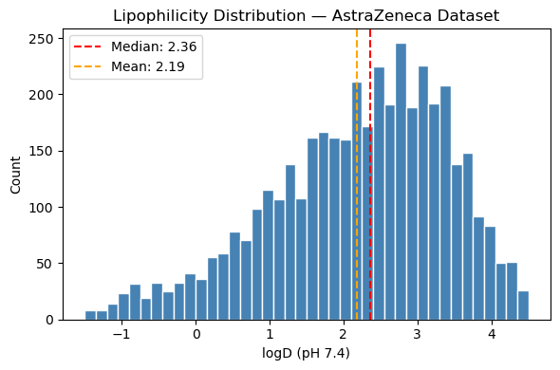
As discussed in the introduction, logP and logD both measure lipophilicity but differ in their treatment of ionization at physiological pH. To quantify how much of the logD variance can be explained by logP alone, we computed the Spearman correlation between the two — finding a moderate positive correlation (ρ=0.394). The wide vertical spread visible in the scatter plot at any given logP value confirms that logP alone is not sufficient for accurate logD prediction, motivating the use of additional descriptors capturing polarity, charge and functional group composition.
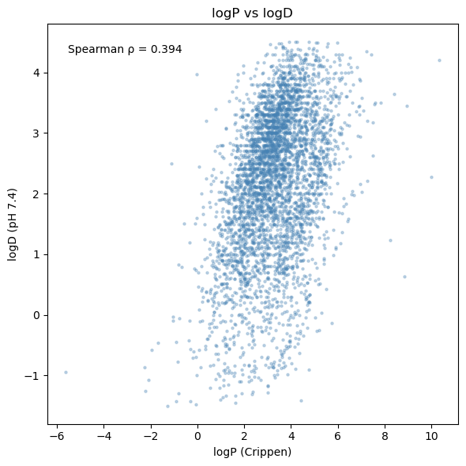
The 4,200 molecules were split into training (2,940), validation (420) and test (840) sets using both random and scaffold strategies. The nearest-neighbour Tanimoto similarity of each test molecule to the training set reveals a mean of 0.639 and median of 0.688 for the random split, compared to 0.571 and 0.593 for the scaffold split — confirming that scaffold splitting creates a harder evaluation where test molecules are more structurally distant from the training set. The scaffold split also shows a broader distribution extending toward lower similarities, while the random split is concentrated at higher values. However, the difference is moderate (~0.1 drop in median), suggesting the dataset's chemical space is relatively homogeneous.
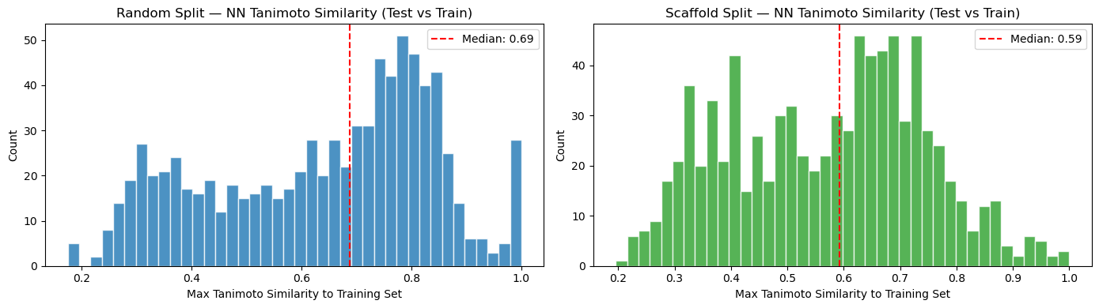
UMAP visualisation confirms this — the dataset forms a dense central cluster with a sparse periphery of structurally unusual compounds. Molecules with similar logD values tend to cluster together, confirming that molecular structure is informative for prediction. In the random split, test molecules (green) dominate both the core and all peripheral regions with train and validation molecules barely visible, reflecting the high structural overlap between partitions. In the scaffold split, train and validation molecules are clearly visible within the core alongside test molecules, and the periphery contains a mix of all three partitions — visually consistent with the lower median similarity.
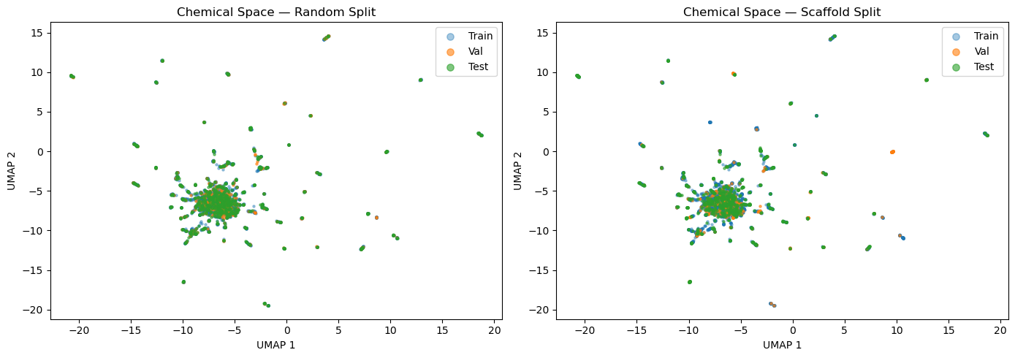

3.2 Baseline Model & Feature Selection
As a diagnostic step before the full model comparison, we trained Linear Regression on all features from each encoding on the random split. The scatter plots reveal clear visual differences — MACCS and Morgan show reasonable but noisy predictions clustering around the diagonal, physicochemical descriptors show the tightest scatter, while RDKit fingerprints produce a completely failed model with predictions compressed into a narrow horizontal band far from the diagonal.
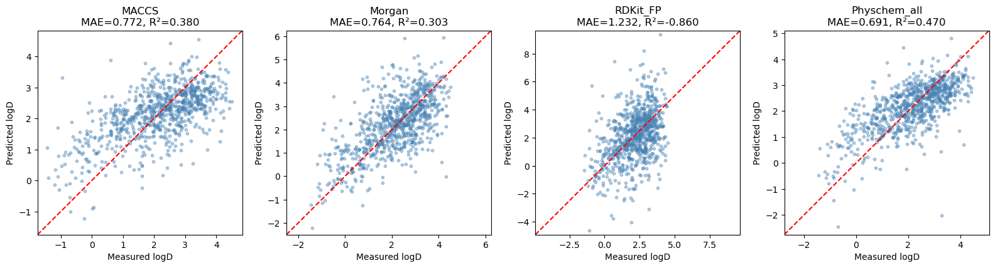

Numerically, physicochemical descriptors performed best (MAE=0.691, R²=0.470), MACCS and Morgan showed moderate performance (R²=0.380 and 0.303 respectively), while RDKit fingerprints produced a severely negative R²=−0.860 — worse than predicting the mean. This failure is explained by the extremely high feature density of 846 active bits per molecule (41.3% of 2048 bits), creating an ill-conditioned problem for linear regression. In contrast, Morgan and MACCS fingerprints have only 48 (4.7%) and 52 (31.1%) active bits respectively, making them more tractable for linear models.
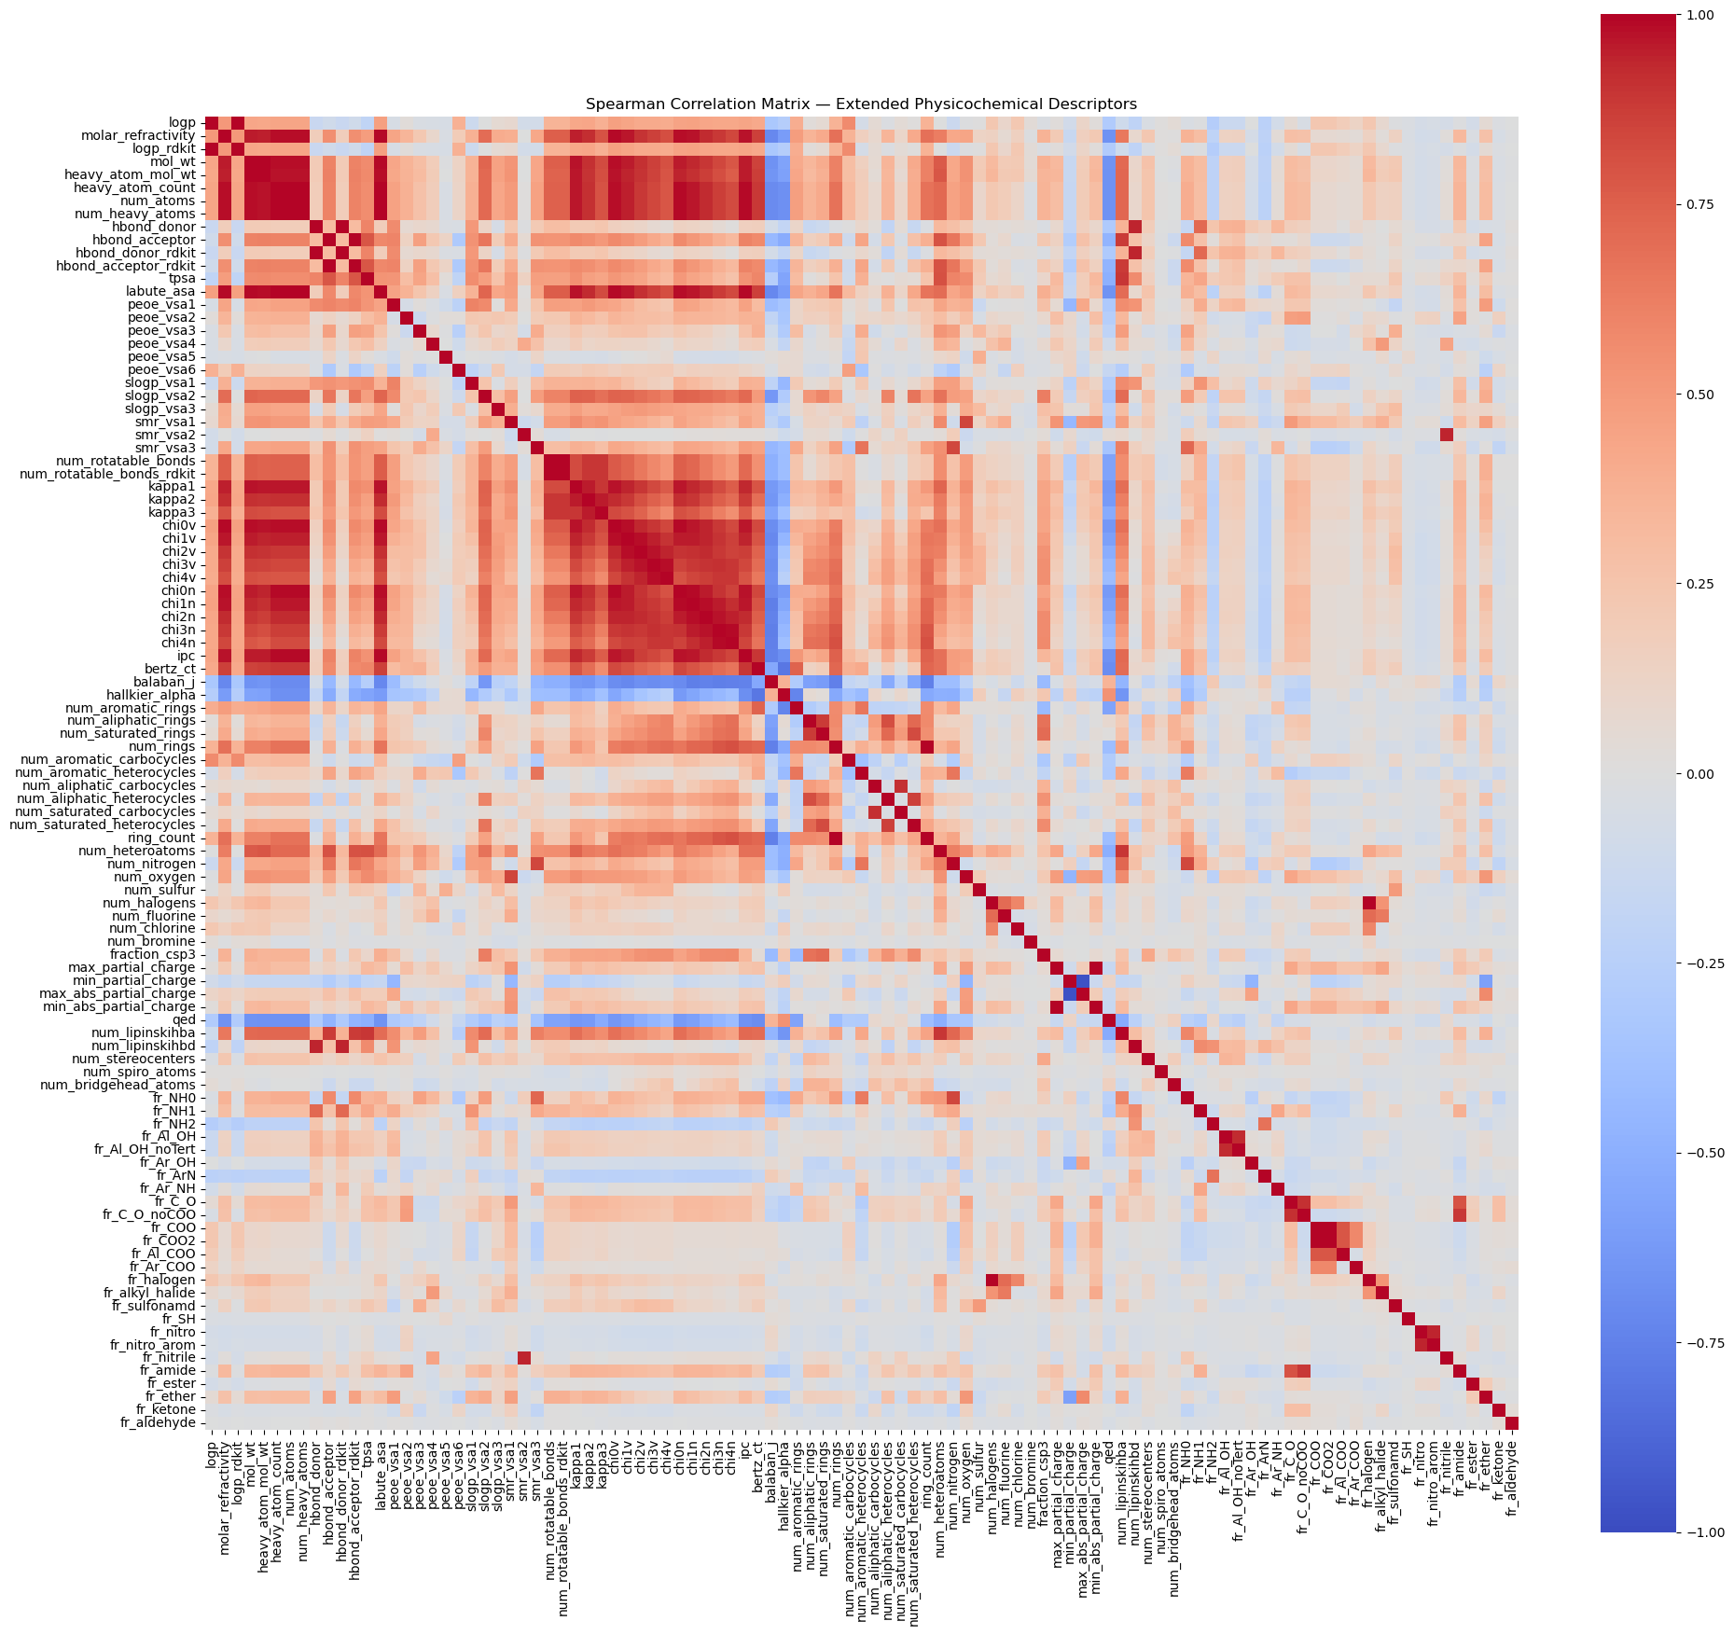
For the physicochemical descriptors, inspection of the Spearman correlation matrix revealed strong redundancy in the 101-descriptor set — with prominent correlated clusters among connectivity/topological indices, molecular size descriptors and lipophilicity variants — motivating the application of CFS.
CFS was applied separately for each model, identifying 49 correlated feature clusters and selecting 33, 26 and 37 features for Linear Regression, Random Forest and XGBoost respectively, with cross-validated R² of 0.440, 0.601 and 0.607. The selected feature sets differ meaningfully across models. Several features appear in all three — most notably `logp_rdkit`, confirming it as the most universally important descriptor for logD prediction, alongside `fr_COO`-related descriptors, surface area terms and hydrogen bond donors. Features such as `max_partial_charge`, `smr_vsa2`, `fr_Ar_OH` and `num_stereocenters` are selected by both RF and XGBoost but not LR, suggesting these capture non-linear signals that only tree-based models can exploit.
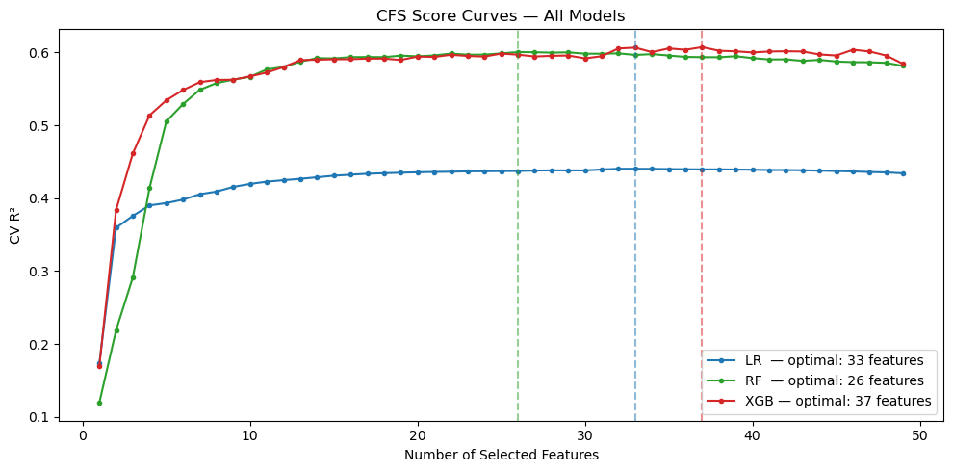
The performance difference between the full 101-descriptor set and the CFS-selected subset was negligible for Linear Regression (R² within 0.025), confirming that CFS removed redundancy without sacrificing predictive power. PFI analysis further confirmed this — after CFS, `logp_rdkit` and `fr_COO` clearly emerged as the most important descriptors, resolving the substitution effect that had diluted importance scores across the full descriptor set.

3.3 Full Model Comparison
We trained and evaluated 24 model/encoding/split combinations — 3 models × 4 encodings × 2 splits. The heatmaps below summarise MAE and RMSE across all combinations for both splits.
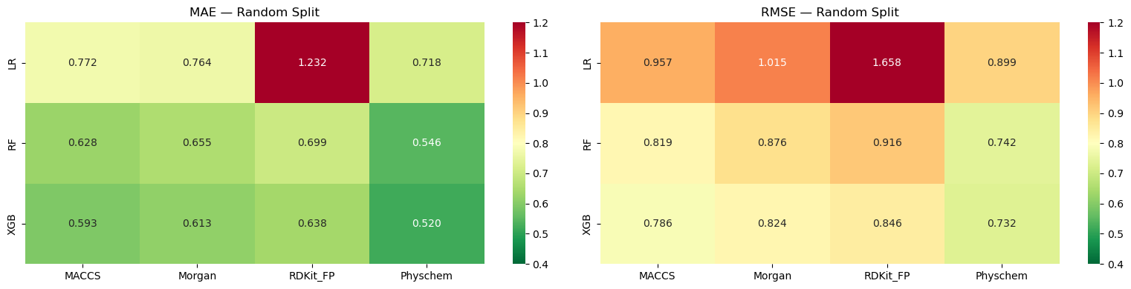
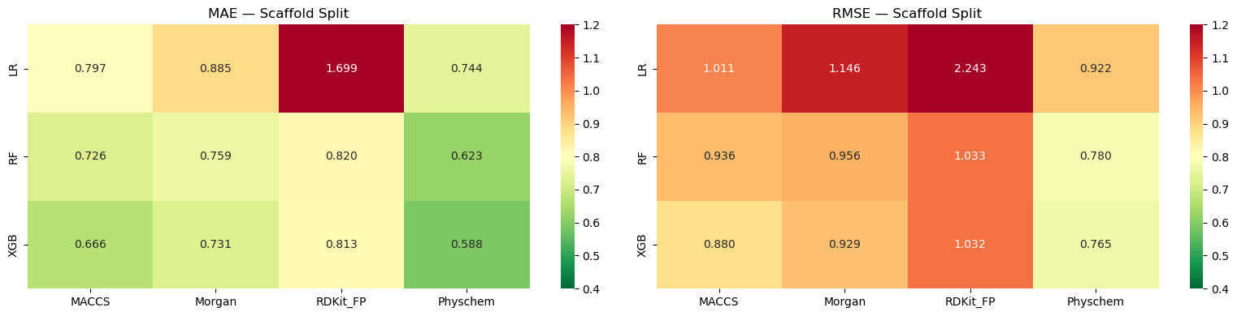
The results reveal consistent patterns. Model ranking is consistent across all encodings and splits: XGBoost > Random Forest > Linear Regression. Encoding ranking is consistent across most combinations: Physchem > MACCS > Morgan > RDKit_FP — the CFS-selected physicochemical descriptors outperform all fingerprint encodings, suggesting that explicit chemical knowledge is more informative for logD prediction than substructural pattern matching alone.

The best overall model is XGBoost with CFS-selected physicochemical descriptors — achieving MAE=0.520, RMSE=0.732, and R²=0.637, on the random split and MAE=0.588, RMSE=0.765, and R²=0.584 on the scaffold split.
The split effect is clearly visible — all models show higher MAE on the scaffold split, confirming that generalising to unseen chemical series is harder. Linear Regression suffers the most (MAE increase of 0.025–0.467) while XGBoost is the most robust (MAE increase of 0.068–0.175), suggesting tree-based models generalise better to new scaffolds.
We further investigated how performance varies with the number of selected features for the best model. All three metrics improve steeply for the first 5–10 features then plateau, with the optimal number of features by test MAE being 25 (MAE=0.580) — slightly fewer than the 37 selected by CFS. The difference is negligible (MAE=0.580 vs 0.588), confirming that the full CFS-selected set is justified and that most predictive signal is captured by the first 20–25 features.
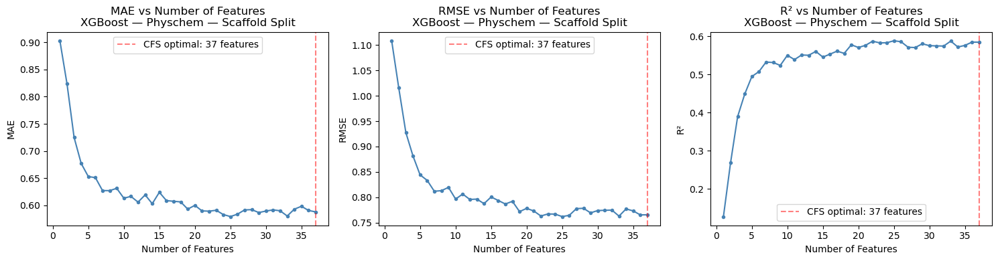
The learning curve shows consistent improvement from MAE=0.927 at n=49 to MAE=0.590 at n=2,939 — an improvement of 0.337 MAE units. The curve has not plateaued at the full training set size, suggesting the dataset is in a data-limited regime and additional logD measurements would meaningfully improve performance.
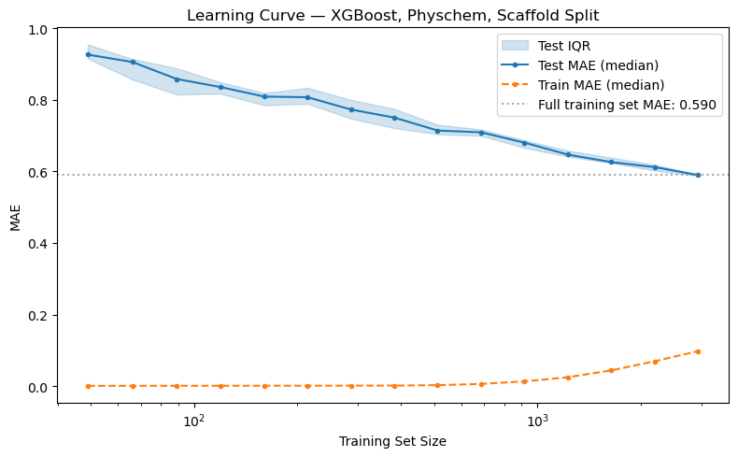

3.4 Performance vs Similarity, Applicability Domain & Explainability
To investigate whether prediction error increases as test molecules become more structurally distant from the training set, we grouped the 840 scaffold test molecules into four similarity bins based on their nearest-neighbour Tanimoto similarity. MAE and RMSE increase monotonically as similarity decreases — from MAE=0.470 and RMSE=0.587 for very similar molecules (nn_sim > 0.7, n=207) to MAE=0.707 and RMSE=0.921 for very dissimilar molecules (nn_sim < 0.4, n=174). The R² plot shows a slight non-monotonicity between the two lowest bins (0.565 vs 0.535), but bootstrap analysis (n=1,000 resamples) confirmed this is a sample size effect — the 95% confidence intervals overlap substantially ([0.412, 0.674] for <0.4 vs [0.392, 0.644] for 0.4–0.5) and the difference is not statistically reliable.
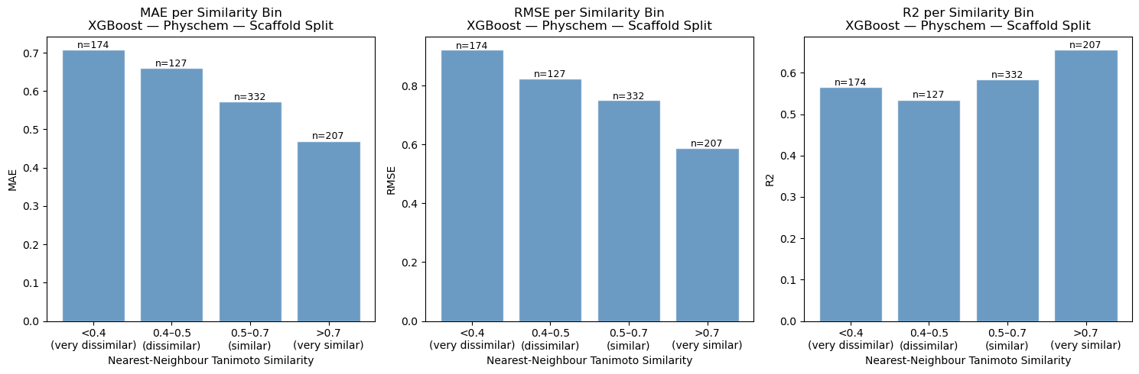

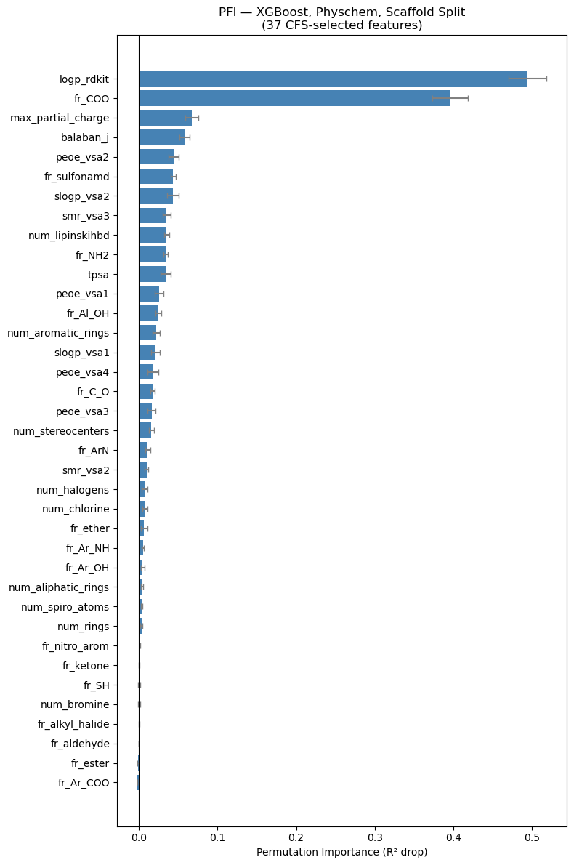
Based on this analysis, we set the applicability domain threshold at nn_sim = 0.5 — the point where the largest single MAE drop occurs, between the 0.4–0.5 bin (MAE=0.660) and the 0.5–0.7 bin (MAE=0.572). With this threshold, 64.2% of test molecules (539/840) fall inside the AD and 35.8% (301) fall outside. Inside the AD, the model achieves MAE=0.533 and RMSE=0.692. Outside the AD, MAE rises to 0.687 and RMSE to 0.881 — a 29% increase in MAE — confirming that structural similarity to the training set is a meaningful indicator of prediction reliability.
Permutation Feature Importance (PFI) on the best model reveals a clear hierarchy — `logp_rdkit` (importance=0.494) and `fr_COO` (0.396) dominate the importance distribution, together accounting for the majority of the model's predictive signal. The remaining 35 features show a gradual and continuous decrease from `max_partial_charge` (0.067) down to near-zero importance, confirming that CFS successfully ensured each selected feature contributes independently. The long tail of near-zero importance features likely captures structural edge cases rather than general lipophilicity trends.
3.5 Kernel Ridge Regression
As a bonus extension, we evaluated two KRR variants on the scaffold split. KRR Tanimoto with Morgan fingerprints achieved MAE=0.664 and RMSE=0.847 (λ=0.1), while KRR Gaussian with the same CFS-selected physicochemical descriptors as XGBoost achieved MAE=0.597 and RMSE=0.793 (λ=0.1, lengthscale=5.0). The Gaussian variant comes remarkably close to XGBoost (MAE=0.588) — a difference of only 0.009 MAE units — despite being a much simpler model with a single lengthscale parameter. KRR Tanimoto shows noticeably more scatter in the predictions, consistent with Morgan fingerprints being less informative for logD than physicochemical descriptors.
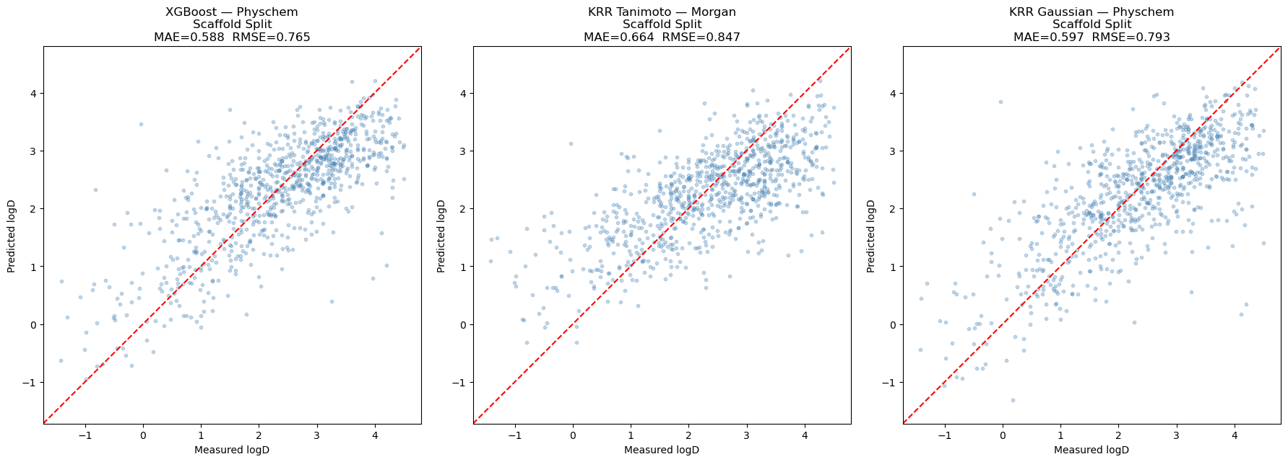
3.6 Graph models results
GNN performance was evaluated across both random and scaffold splits. While the classical XGBoost models performed well, the GNNs, specifically the GIN architecture, demonstrated the highest predictive power on the scaffold split.
Split | Model | RMSE | MAE | R2
Random | GCN (scratch) | 0.878 | 0.691 | 0.478
Random | PyG GCN | 0.713 | 0.554 | 0.656
Random | PyG GIN | 0.667 | 0.508 | 0.699
Scaffold | GCN (scratch) | 0.904 | 0.714 | 0.420
Scaffold | PyG GCN | 0.666 | 0.524 | 0.686
Scaffold | PyG GIN | 0.500 | 0.379 | 0.823

The scratch GCN was the weakest model because of a few clear technical reasons.
First, it doesn't have much information to work with; it only looks at the atomic number, missing out on important chemical details like aromaticity and hybridisation. The PyG models, on the other hand, use a much richer set of features.
Second, the scratch model oversimplifies chemical bonds into a basic "yes or no" connection, while the PyG models look at the specific types of bonds.

The way the models gather information from surrounding atoms also matters. The standard GCN tends to "blur" the details of a molecule by using means, while the GIN model is much better at keeping track of unique local structures, like specific functional groups, by summing and using non-linear MLP.
When looking at the results, the PyG GCN and GIN models did better on the harder scaffold split than on the random one. Even though this is unusual compared to standard models, it shows that GNNs are very good at recognising structural patterns when they are given high-quality data.

4. Discussion (JUST SOME BS IDEAS OF WHAT WE COULD WRITE HERE, LEAVING IT UP TO SASHA)
The best performing model — XGBoost with CFS-selected physicochemical descriptors — achieved RMSE=0.732 on the random split, which is competitive with the MoleculeNet benchmark of RMSE~0.65 reported for graph convolution models (Wu et al., 2018). This is notable given that our approach relies entirely on hand-crafted descriptors rather than learned molecular representations, suggesting that explicit physicochemical knowledge remains highly competitive for logD prediction on this dataset.
The KRR Gaussian result (RMSE=0.793) further supports this — a simple kernel method with a single lengthscale parameter achieves nearly identical performance to XGBoost, suggesting the logD–descriptor relationship is smooth and well-structured enough to be captured without complex models.
The scaffold split results (MAE=0.588) are more informative than the random split for real drug discovery scenarios, where models must generalise to structurally novel compounds. The moderate difference between the two splits (~0.07 MAE) suggests this dataset's chemical space is relatively homogeneous, which likely limits the apparent generalisation challenge. Models evaluated on more chemically diverse datasets would be expected to show larger performance gaps between splits (Lenselink & Stouten, 2021).
The applicability domain analysis demonstrated that structural similarity to the training set is a meaningful predictor of reliability — predictions for molecules with nn_sim < 0.5 showed a 29% increase in MAE compared to those inside the AD. In a real drug discovery setting, this provides actionable guidance: predictions inside the AD can be used with reasonable confidence, while out-of-AD predictions should trigger experimental follow-up.
Several limitations should be noted. The learning curve analysis shows the dataset is in a data-limited regime — performance had not plateaued at n=2,939, suggesting that additional experimental measurements would improve generalisation. The study is also limited to a single dataset, and performance on more chemically diverse collections may differ. Finally, our classical ML models do not provide uncertainty estimates, which would be valuable for the applicability domain flagging. Graph Neural Networks, which learn molecular representations directly from structure, represent a natural next step — their performance on this dataset is explored in the bonus section.

